**Connect Now Setup**

**Node.js Installation**

**Steps:**

1. Download windows installer from the below website:

<https://nodejs.org/dist/v6.10.3/node-v6.10.3-x64.msi>

1. Run the installer (the .msi file you downloaded in the previous step.)
2. Open cmd.
3. Check Node.js version by: ’node –v’ whether it is the desired version or not.
4. Set the desired folder location and enter the proxy configuration.

* npm config set proxy <http://proxy.agl.int:8080>
* npm config set https-proxy <http://proxy.agl.int:8080>

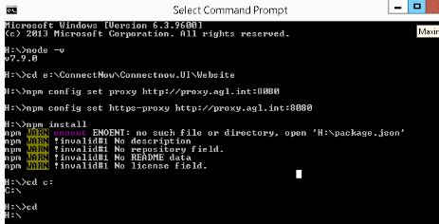

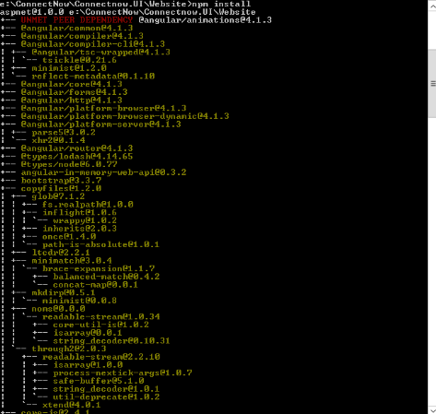

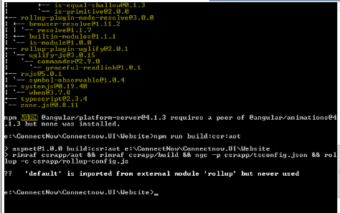

**Developer Machine Set UP for Connect Now:**

1. Install Internet Information Service (IIS) in the developer machine.
2. The IIS should contain the following features enabled.

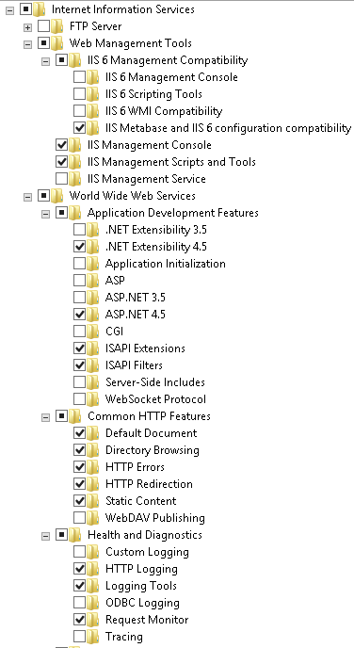

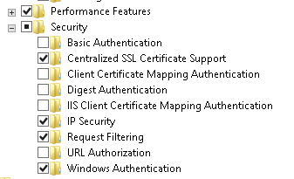

1. Install visual studio 2015 SP Update 3 from the below location

<R:\PWKS Team\Personal\Tamal_Mukherjee\VS 2015\tools\VS SP Update 3>

Copy the .iso file from the folder to your local machine, and install the file in admin mode.

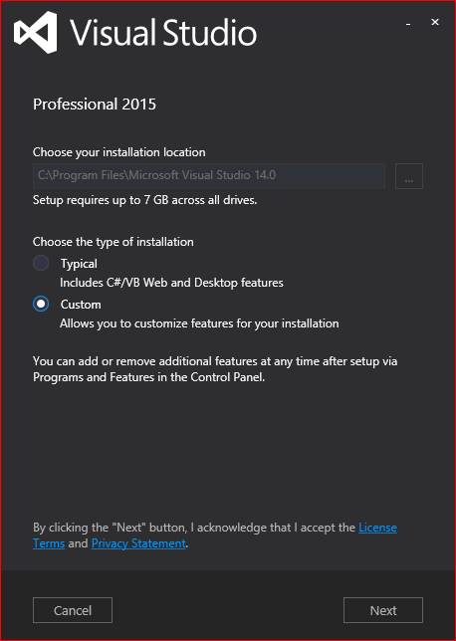

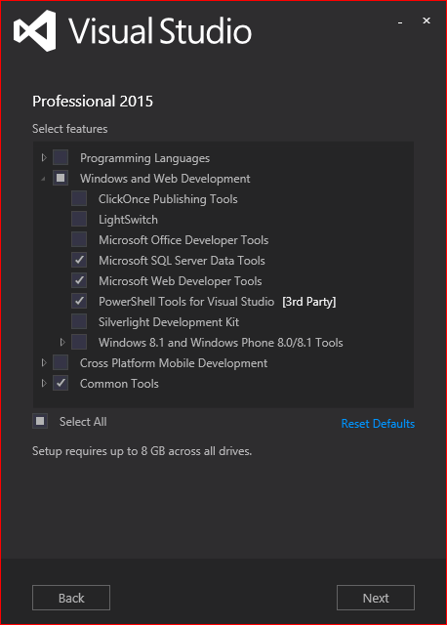

1. Install Azure sdk. It is available in the below location :

\\colgen02\Groups\PWKS Team\Personal\Tamal_Mukherjee\VS 2015\Azure sdk

Copy this folder to your local machine, and install the files sequentially in admin mode.

1. Open host file with note pad in admin mode and update it with following ips.

127.0.0.1              connectnow

127.0.0.1              harcourtsconnect

127.0.0.1              randwconnect

1. Connect to GitHub and pull the code and start working.

**TypeScript tool installation**:

<\\colgen02\Groups\PWKS Team\Personal\Tamal_Mukherjee\VS 2015\tools>

Copy the TypeScript_Dev14Full.exe from the folder to your local machine, and install the file in admin mode.

CMD Configuration(after Typescript installation):

* Open CMD in the desired folder location in admin mode and type: ‘npm install’.
* Type ‘npm run build:csr:aot’.
* Now open visual studio in admin mode. It is ready for use.

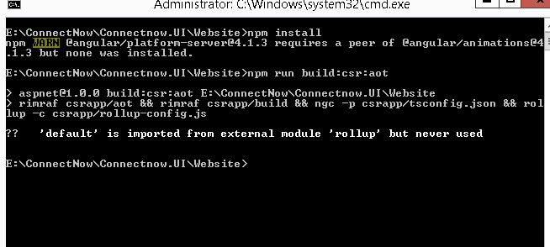

Install Visual Studio Code for angular 2 debug :

* Location R:\PWKS Team\Atari.
* Copy to your machine.
* Install in admin mode.
* After VS Code is installed install angular essentials and chrome debugger in VS Code.